**Set+1_Descriptive+statistics+Probability+(2) (1)**

1. Look at the data given below. Plot the data, find the outliers and find out $μ, σ, σ^{2}$

**Code:(**

**import numpy as np**

**import pandas as pd**

**import matplotlib.pyplot as plt**

**import seaborn as sns**

**%matplotlib inline**

**Data=pd.Series([24.23,25.53,25.41,24.14,29.62,28.25,25.81,24.39,40.26,32.95,91.36,25.99,39.42,26.71,35.00])**

**name_of_company=['Allied Signal','Bankers Trust','General Mills','ITT Industries','J.P.Morgan & Co.','Lehman Brothers',**

**'Marriott','MCI','Merrill Lynch','Microsoft','Morgan Stanley','Sun Microsystems','Travelers','US Airways',**

**'Warner-Lambert']**

**# Pie Chart**

**plt.figure(figsize=(6,8))**

**plt.pie(Data,labels=name_of_company,autopct='%1.0f%%')**

**plt.show()**

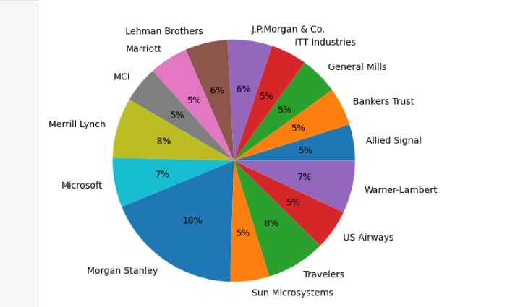

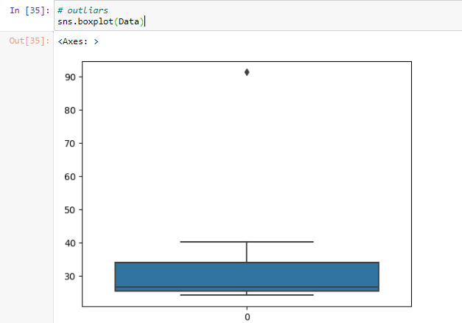

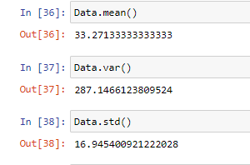

**)**

1. 

Answer the following three questions based on the box-plot above.

What is inter-quartile range of this dataset? (please approximate the numbers) In one line, explain what this value implies.

Ans: **Approximately (First Quantile Range) Q1 = 5 (Third Quantile Range) Q3 = 12, Median (Second Quartile Range) = 7 (Inter-Quartile Range) IQR = Q3 – Q1 = 12 – 5 = 7 Second Quartile Range is the Median Value**

What can we say about the skewness of this dataset?

Ans: **Right-Skewed median is towards the left side it is not normal distribution**

If it was found that the data point with the value 25 is actually 2.5, how would the new box-plot be affected?

Ans: **In that case there would be no Outliers on the given dataset because of the outlier the data had positive skewness it will reduce and the data will normal distributed.**



Where would the mode of this dataset lie?

Ans: **The mode of this data set lie in between 5 to 10 and approximately between 4 to 8**

Comment on the skewness of the dataset.

Ans: **Right-Skewed. Mean>Median>Mode**

Suppose that the above histogram and the box-plot in question 2 are plotted for the same dataset. Explain how these graphs complement each other in providing information about any dataset.

Ans: **They both are right-skewed and both have outliers the median can be easily visualized in box plot where as in histogram mode is more visible.**

1. AT&T was running commercials in 1990 aimed at luring back customers who had switched to one of the other long-distance phone service providers. One such commercial shows a businessman trying to reach Phoenix and mistakenly getting Fiji, where a half-naked native on a beach responds incomprehensibly in Polynesian. When asked about this advertisement, AT&T admitted that the portrayed incident did not actually take place but added that this was an enactment of something that “could happen.” Suppose that one in 200 long-distance telephone calls is misdirected. What is the probability that at least one in five attempted telephone calls reaches the wrong number? (Assume independence of attempts.)

Ans: **IF 1 in 200 long-distance telephone calls are getting misdirected.  
probability of call misdirecting = 1/200 Probability of call not Misdirecting = 1-1/200 = 199/200 The probability for at least one in five attempted telephone calls reaches the wrong number Number of Calls = 5 n = 5 p = 1/200 q = 199/200 P(x) = at least one in five attempted telephone calls reaches the wrong number P(x) = ⁿCₓ pˣ qⁿ⁻ˣ P(x) = (nCx) (p^x) (q^n-x) # nCr = n! / r! * (n - r)! P(1) = (5C1) (1/200)^1 (199/200)^5-1 P(1) = 0.0245037**

1. Returns on a certain business venture, to the nearest $1,000, are known to follow the following probability distribution

|  |  |
| --- | --- |
| x | P(x) |
| -2,000 | 0.1 |
| -1,000 | 0.1 |
| 0 | 0.2 |
| 1000 | 0.2 |
| 2000 | 0.3 |
| 3000 | 0.1 |

1. What is the most likely monetary outcome of the business venture?

Ans: **The most likely monetary outcome of the business venture is 2000$ As for 2000$ the probability is 0.3 which is maximum as compared to others**

1. Is the venture likely to be successful? Explain

Ans: **Yes, the probability that the venture will make more than 0 or a profit p(x>0)+p(x>1000)+p(x>2000)+p(x=3000) = 0.2+0.2+0.3+0.1 = 0.8 this states that there is a good 80% chances for this venture to be making a profit**

1. What is the long-term average earning of business ventures of this kind? Explain

Ans: **The long-term average is Expected value = Sum (X * P(X)) = 800$ which means on an average the returns will be + 800$**

1. What is the good measure of the risk involved in a venture of this kind? Compute this measure

Ans: The good measure of the risk involved in a venture of this kind depends on the Variability in the distribution. Higher Variance means more chances of risk Var (X) = E(X^2) –(E(X))^2 = 2800000 – 800^2 = 2160000